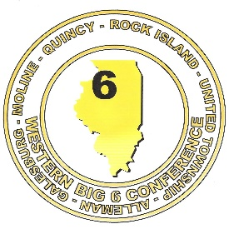**WESTERN BIG 6 CONFERENCE**

**SPRING SPORTS – 2019**

**The following athletes were selected by the head coaches of each sport as ALL CONFERENCE 2019**

**BASEBALL ALL CONFERENCE**



**GIRLS’ SOCCER ALL CONFERENCE**

**FIRST TEAM**

***Name Year Position School***

Anna Darrow Senior Center Midfield Alleman

Julia DeSmet Senior Center Midfield Alleman

Alli Edwards Junior Defender Alleman

Karima Rangel Junior Forward Moline

Caroline Hazen Freshman Forward Moline

Carson Boyer Senior Center Back Quincy

Emma Kroeger Senior Forward Quincy

Hayley Milhauser Senior Center Forward Quincy

Kayla Garcia Senior Midfield Rock Island

Uda Kimba Freshman Defense/Midfield Rock Island

Madison Gordon Junior Midfield United Township Aria Fix Junior Forward United Township

Kayla Dorn Sophomore Forward United Township

Ashley Boyer Junior Goalkeeper Quincy

HONORABLE MENTION

*Name Year Position School*

Elizabeth Galvin Freshman Midfield Moline

Allie Van Junior Defender Moline

Lylia Gomez Sophomore Midfield Moline

Makayla Rangel Junior Defender Moline

Meagan Mero Junior Midfield Quincy

Samantha Boyer Senior Midfield Quincy

Alexis Miranda Senior Forward Quincy

Billi Fleck Senior Goalkeeper Alleman

Allison Mirimanian Sophomore Goalkeeper United Township

**SOFTBALL ALL CONFERENCE**



**BOYS’ TENNIS ALL CONFERENCE**

Name School Year

Greysen Arns Quincy Senior

Blake Hayden Quincy Senior

Isaiah Mowen Galesburg Junior

Cole Petrie Galesburg Senior

Dylan Wiemers Moline Junior

Zach Willing Quincy Junior

**BOYS’ TRACK ALL CONFERENCE**



**GIRLS TRACK ALL CONFERENCE**

