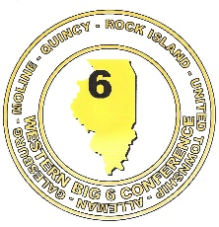Western Big 6 Conference

**WINTER 2018 – 2019 ALL CONFERENCE ATHLETES**









