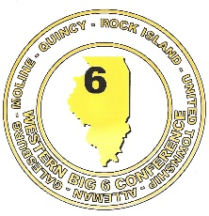Western Big 6 Conference

**WINTER 2017 – 2018 ALL CONFERENCE ATHLETES**









**WESTERN BIG 6 BOYS’ SWIMMING**

**2017-18 ALL CONFERENCE TEAM**

Name Year School

Avery Fowler Senior Moline

Drew Giles Junior Galesburg

Remi Greko Sophomore Moline

Alex Klumb Senior Moline

Ethan Luong Senior Moline

Austin Morris Junior Moline

Peter Son Junior Moline

Jack Thompson Senior Moline

Austyn White Senior Galesburg